

**School of Science and Technology**

**CSD3999  
Software Development Project**

**M00577156**

**Jovanie Lawrence**

**Literature Review**

Literature Review

The educational environment will be running as a Docker image on Docker and hosted in AWS. By storing it on a cloud services students will be able to access the software remotely. The students are required to register their details, log in to have access to the services. Once logged in, students will successfully able to commence web developing.

**Introduction**

The need for containerisation is imperative due to the enormous growth of technology. There is a need for an environment that will simplify the way technology is used for learning. The need for installing different runtime environments to run different technology has increased dramatically which will inevitably cause installation problems. The following review of literature confirms problems with the installation of different technologies and the solution which is to build an educational environment that will run several software using containers on Docker.

**Virtualisation**

The term is given to the capability of managing operating systems on a single hardware simultaneously. The hardware can run the virtualisation software(virtual machine or VM) which will enable users to run different operating systems independently on their own separate environment. A virtual machine possess its own central processing unit (CPU) as well as its own storage capacity and operating system.

It may seem as if it’s a new technology by way of popularity, but virtualisation has existed primarily since the 1960s. IBM implemented virtualisation to allow mainframes computers to process and run more than one application at the same time.

**Types of Virtualisation**

There are different types of virtualisation that is progressing in the industry and three types will be discussed in this section.

**Network**

This type of virtualisation is designed to handle complexities by managing network resources, such as bandwidth, and break them down into smaller portions to maintain a smooth management of files. This process is all done in the background in such an intricate way that the user experience will not be interrupted.

**Desktop**

Is when a workstation is independent from the physical client. This technology allows a type of client-server technology model because the desktop is stored on a server rather than its physical host. This enable users the convenience of accessing their desktops remotely by using a smartphone or a tablet for example,

**Server**

Refers to the ability of transforming a physical server into several virtual servers. This is done by a VM which enables each virtual server to run more than one operating system.

Virtualisation is revolutionary and is very popular for both large and small organisations. There exist different containerisation and virtualisation software and this section will be focused on some similar examples that are widely used.

**Containerisation**

This is a lightweight alternative to virtualisation. The process encapsulates an entire environment into a container which makes it simpler to load an application. Moreover, this process has gain prominence since 2013 with the introduction of Docker. The Docker containers enable users to run application on physical hardware to servers and virtual machines.

**Wine**

Wine does not use containerisation but is one of the early technologies of virtualisation. Released initially in 1993, it fundamentally runs Windows application on Linux and MacOS machines. This open-source software differs from Docker. “Instead of simulating internal Windows logic like a virtual machine or emulator, Wine translates Windows API calls into POSIX calls on-the-fly, eliminating the performance and memory penalties of other methods and allowing you to cleanly integrate Windows applications into your desktop”(Wine HQ, 2018).

**Xen**

The Xen project is an open source virtualisation platform that runs a hypervisor for Linux kernel. Xen is capable of running multiple virtual machines with each running their own respective operating systems on physical host.

**Cygwin**

Is a cross-platform environment that enables users to run Windows based development and testing on Linux/Unix platforms. In addition, Windows applications can be launched on Linux via Cygwin. This provides a Linux like environment experience for Windows users and viscera for users of Linux systems.

**VMware**

Provides platform virtualisation while using a hypervisor that runs on a server hardware. A hypervisor is an important process that does the separation from operating system from the hardware. This enables the physical host to manage a virtual machine.

**Docker**

Does not use a traditional hypervisor like virtual machines. Docker containers utilises Linux Containers (LXC), which is an operating system level virtualisation tool designed to run numerous Linux based applications on a kernel. Therefore, Docker containers can only run in a Linux type environment while running Linux based applications.

**VMs vs Docker**

Both uses virtualisation in some form, However, Docker containers can be fasters to run application due to the encapsulation process. With a hypervisor, which means that applications can run on Windows or other operating systems, the VM could take longer to launch. The encapsulated container has already gone through the process of booting up and is ready to be built into a Docker image. Please see “Figure 1” for a graphical representation of the VM vs Docker debate which shows the architecture of both virtual machines and Docker. Note that VMs use a hypervisor while Docker does not, which results in a faster running of applications.

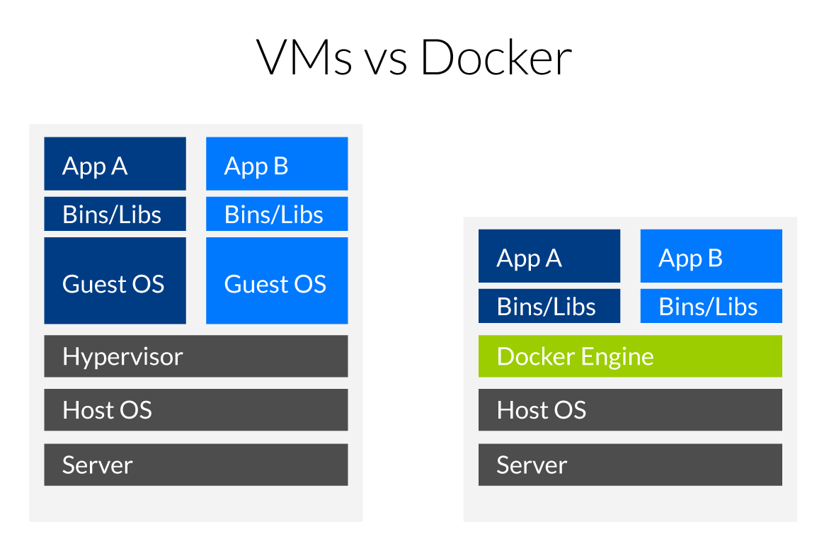

Figure : VM vs Docker image (Docker vs Vm, 2017)

Cloud computing

Computing on the cloud is a revolutionary in technology. “Cloud computing is the on-demand delivery of compute power, database storage, applications, and other IT resources through a cloud services platform via the internet with pay-as-you-go pricing” (Amazon web services, 2018).

Virtualisation powers the cloud with the process of separating computing environments from physical machines. The cloud does similar practices to virtual machines and is all based on virtualisation. It is impossible to have cloud computing without virtualisation.

There are several factors in cloud computing that makes it irresistible to users. Storage is the possibly what makes the cloud special due to the capabilities to store items such as photos on a cloud account, which the user can access at will without using hardware storage space. It does this by providing users’ access to servers that operate a series of other web applications.

EC2

“Amazon Elastic Compute Cloud (Amazon EC2) provides scalable computing capacity in the Amazon Web Services (AWS) cloud “ (Amazon 2018). Building and deploying Docker containers can be very convenient due to containerisation which compresses all of the hardware configurations, operating systems and software settings all placed in a container. However, when a large number of containers are being deployed it can be very problematic in terms of container management. It would be convenient for a service to manage the applications on the cloud, cluster configuration management and deployment. This will make it much simpler for users to have one service to that will manage all of these configurations on the cloud.

This elastic container service is a high performance container management service that provides a prompt deployment and management of distributed applications on numerous virtual servers . It makes it easier and inexpensive for users to gain access to the functionalities of the servers on the cloud.

Docker on the cloud

EC2 instances are based on both Linux and Windows and EC2 will connect to the cloud based on the machine OS. EC2 can launch and run Docker containers across numerous Amazon EC2 instances using APIs. It schedules containers to find the best placement on the cloud based on the physical features of a machine such as CPU and memory requirements. Alternatively, users can manual use their own schedulers if desired EC2 offer this feature but it is recommended to allow the container service automatically choose container placement. In addition, EC2 allows for a mixture of different containers to run simultaneously on the cloud. For example, it is possible to run a web server application and a MySQL container and the container service will schedule and run them together and at the same time.


            Deploying an instance from a template
        

Figure : AWS EC2 Architecture(AWS 2018)

Virtual desktop

The process of storing an entire environment not by the traditional way of on a personal computer itself, but on a remote server. The process uses desktop virtualisation therefore all software and operating systems are detached from the physical client. A hypervisor creates a simulation of a desktop environment which enables users to access their personal desktop on a PC, tablet or smartphone anywhere at any time.

VDI

Virtual desktop solutions uses virtual desktop infrastructure (VDI) for management. VDI is a desktop virtualisation method that enables a user’s desktop to run in a virtual machine which is stored on datacentre servers. It allows users that flexibility and mobility to access their desktops.

RDS

Remote Desktop Service is a virtual desktop technology that allows multiple users to use the same virtual machine and server operating system. This Microsoft Windows service speeds up the deployment of desktops and enables users to connect to remote servers and run applications.

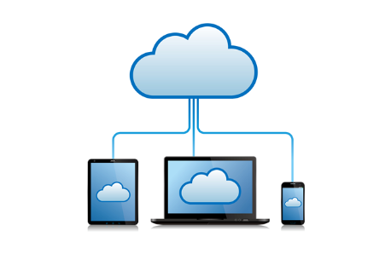

Figure :Virtual desktop(Fujitsu 2015)

References

Ec2

https://docs.aws.amazon.com/AWSEC2/latest/UserGuide/concepts.html